CHAPTER III
METHODOLOGIES
A. Existing Algorithm
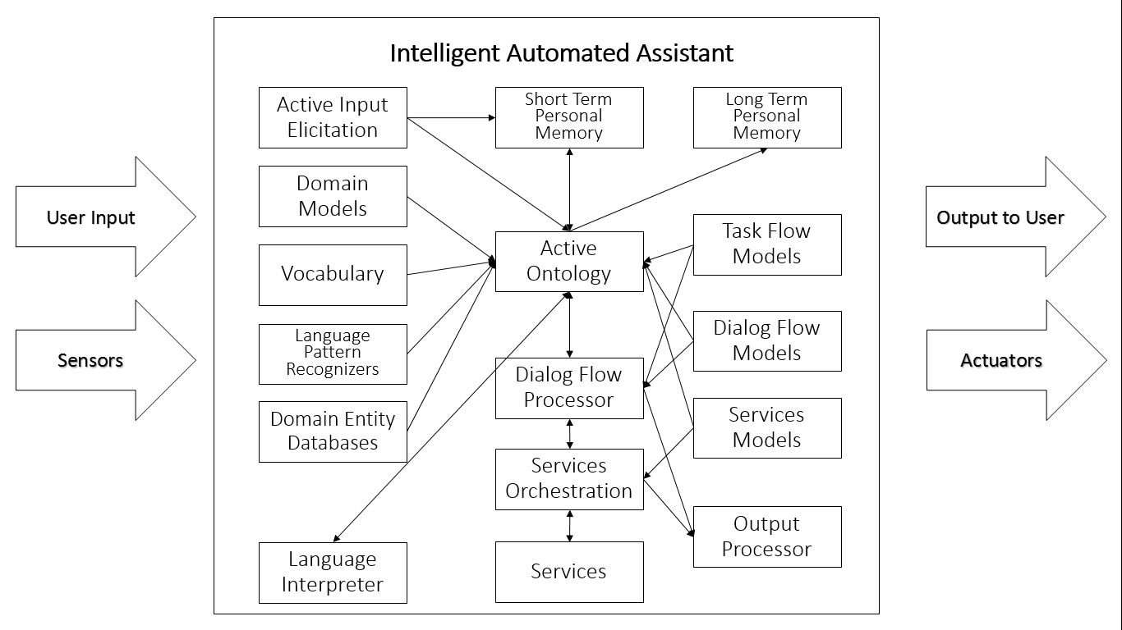
This study is focused on Intelligent Personal Assistant Development Platform. Before discussing the actual algorithm or method to be used in the development phase, this section will briefly discuss a typical IPA Algorithm and how it works. This concept is important to fully understand the relevance of the to-be-discussed core algorithms and how will it all be combined to build a development platform.
Figure 2. A typical IPA Algorithm
On the above diagram, we can see how many components work separately inside an IPA Core. Language Processing, Vocabularies, Dialog Management etc. act as separate modules and the tedious tasks of incorporating and making them work altogether is the burden of the developer.
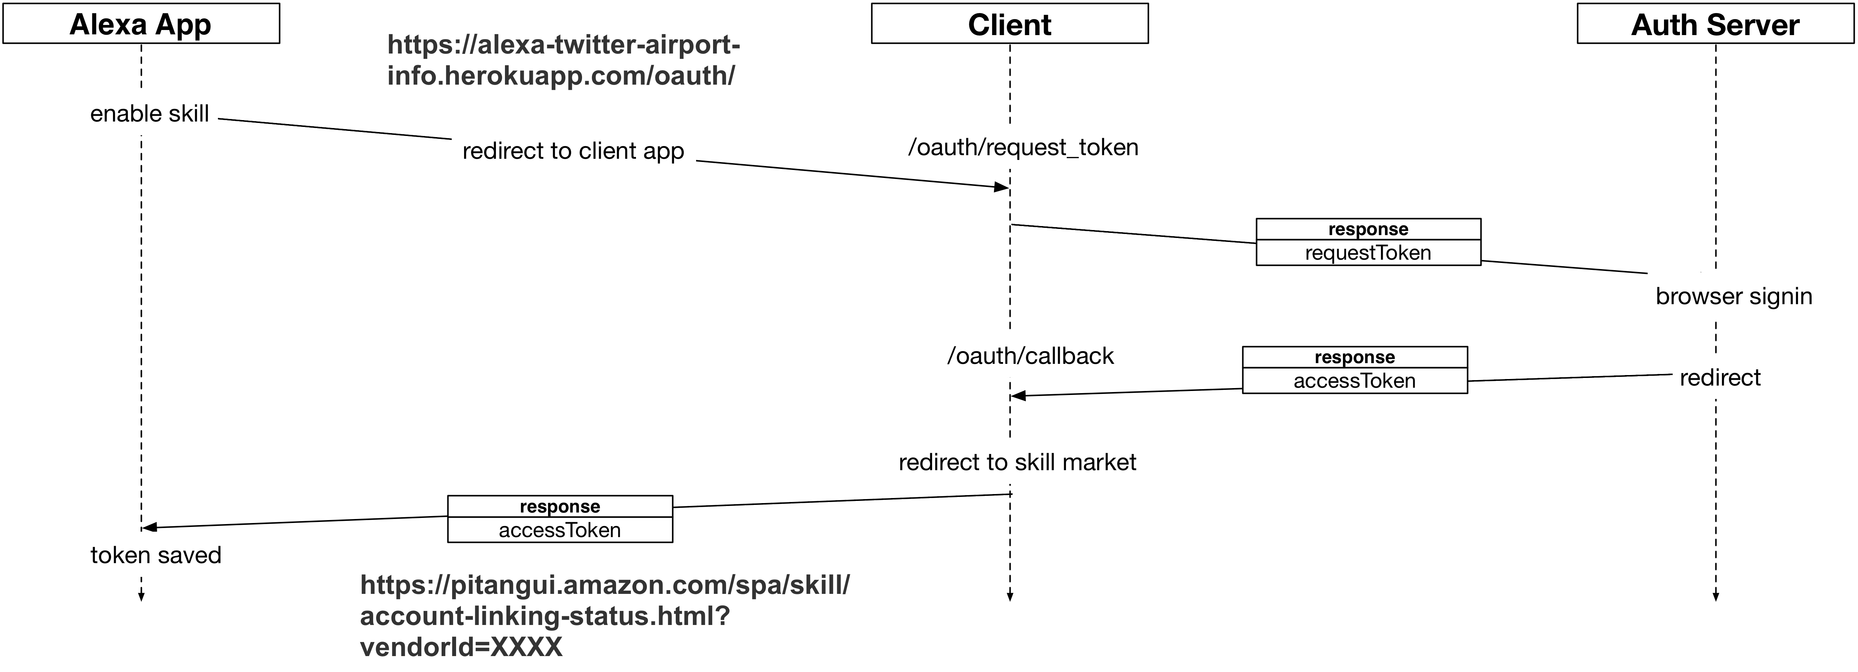
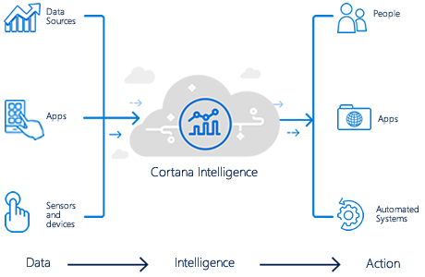
Here are other samples of the high-level architecture of some famous Intelligent Personal Assistants (detailed algorithm is closed sourced):
Figure 3. Amazon Alexa
Figure 4. Microsoft Cortana
B. Proposed Algorithm
I. Intelora Core
After thorough analyzation and research, we conceptualized and developed Intelora, a platform that will simplify the above stated process. This is done by grouping the three main components (Speech Recognition, Language Understanding, Speech Synthesis) and combining them to develop a core which will act as the central processing module and message bus. External and Add-On modules and services will be then incorporated by accessing the Platform's API.
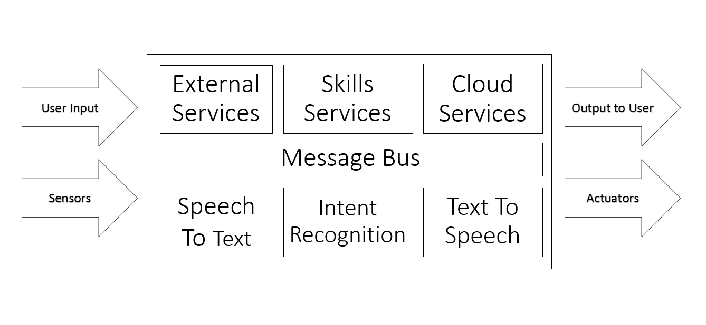
Figure 3. Intelora Core (Proposed Algorithm)
Intelora Core is the primary module that makes up the Intelora Intelligent Personal Assistant Development Platform. Intelora makes use of the Adapt Intent Parser, Google Speech, and Mimic.

II. Usage and Features
The idea behind the platform is to provide developers and enthusiasts a way to develop and customize their own Intelligent Personal Assistant from ground up. Users need to build and setup the system from the ground up.
The Intelora platform offers great advantages:
The first and greatest of which is its permissive, open source license. Intelora allows developers and users to take, extend, and integrate the software anyway they want.
The goal of Intelora is to allow the software to run on the lightest hardware possible. One of the goals is to allow Intelora to run in a wide variety of everyday devices such as mobile phones, desktops, laptops and embedded systems.
It is our hope is for Intelora to reach many developers and contributors to ensure that the future of artificial intelligence is open for all.
Thru Intelora you can develop your own IPA that is...
Always Learning. Intelora uses open software to process natural language, determine your intent and act. As more and more people adopt Intelora and develop modules the platform will learn to be more capable, more useful and more fun.
Always Changing. As more programmers and makers find new things they want Intelora to do, we’ll share their hacks, tweaks, extensions and modules with the Intelora community through a web-based repository.
Always Listening. Intelora is always listening. When you call your assistant, it will answer.
Thru Intelora you can develop your own IPA that can...
Increase Productivity. Integrate a host of professional functions – Control scenes to conserve power, grant office access with your voice, get that coffee rolling! Intelora is the future – a voice activated AI controlling your professional Internet of Things.
Encourage Creativity. Makers everywhere can use Intelora up, add components, change software, extend and hack it. Whether Intelora is in your garage or your local makerspace you will benefit from an intelligent always on interface to your next project.
Make Your Home Smart. Naturally control all your media and devices with the sound of your voice. Adjust your thermostat, turn on your lights, water your lawn, play your favorite movie. Just speak naturally and your IPA's there to do your bidding.

III. Core Overview
Intelora Core contains four main services - the messagebus, the skills service, the speech client, and the command line interface. Only one of the command line client and speech client need to be run, as they both provide methods of interacting with the Intelora Platform. This section will cover what these services do on a general level.
Process:
1. A user says a phrase including the wake word
2. The speech client strips out the wake word and sends the audio to a speech to text service
3. The speech to text service sends back the parsed text, which is sent on the messagebus by the speech client
4. Adapt gets the text and tries to match it to an intent registered by one of the skills
5. If it succeeds, the intent it finds is sent on the messagebus, along with what keywords it found
6. The skills service picks up the message and gives it to the skill matching the intent
7. The skill processes the message, does some action with it, and sends any message to be spoken on the messagebus
8. The speech client takes the message and sends it to a text to speech service (Mimic by default)
The command line client essentially shortcuts directly to sending the text to Adapt, as there is no speech to text service required. It also handles sending a speak message to the chosen text to speech service, like the speech client does.
Messagebus
The messagebus is how all the different parts of Intelora communicate between each other. It does this by sending different types of messages that contain needed information. For example, one part of Intelora could send a speak message that contains something for the IPA to say. The message would be carried over the messagebus, and any other service connected to it could read the message and parse it. In the core, the speech or command line client would pick up the message and then convert it into speech.
The messagebus is also hosted as a web socket that other things can communicate with. By default, this web socket is set on localhost:8000/events/ws.
Speech Client
There are a few components to the speech client. There is the AudioConsumer, AudioProducer, and within that the listener. There exists a shared queue of audio files between the consumer and producer. The producer grabs segments of audio from the listener and the consumer uses the audio to send to an external STT engine and emit the result as an utterance.
Listener
The listener figures out what pieces of audio Intelora should record and respond to. It first detects its wake word using pocketsphinx on around the last two seconds of audio. Audio older than two seconds is discarded. After detecting its wake word, it begins recording until when it thinks the user has finished speaking. This is estimated using a heuristic described below.
Phrase Heuristic
Essentially, the listener records until the "noise level" falls at or beneath 0. The "noise level" is a sort of estimate of the relative noise in the past few seconds. Every time the noise is above a certain threshold, the "noise level" increases. On the contrary, the opposite happens when the noise is lower than the threshold. By keeping track of this number, small separated noises will not affect the noise level as much as long contiguous noises most likely indicative of voice.
Another technique the listener uses is waiting for audio when it knows there should be more. If you say the wake word without any following noise Intelora will wait for input for another 3 to 4 seconds. The sum of audio that is above the threshold is maintained while recording a phrase. The audio will only return when both the noise level is at 0 and the length of audio above the threshold is past a minimum amount.

Skills Service
The skills service has two main components - the skills themselves and the Adapt intent parser.
Skills
A skill consists of vocabulary files (a list of phrases or words that the IPA should respond to), dialog files (a list of phrases that the IPA will say in response to something in the skill), and a Python file. This Python file determines how the vocabulary maps to each intent, as well as what actions the IPA will take when an intent is found (ranging from saying something to turning off the lights).
Adapt
In short, adapt takes in a sentence and attempts to find what the intent of it is by looking for matching words and phrases from intents and vocab registered by different skills.

C. Simulation
1. Intelora waits for the wake word.
2. Once wake word is detected, Intelora will then listen for the user’s request.
3. Recorded request will then be transcribed into text using neural networks.
4. Text will then be evaluated to recognize intent.
5. Intent will then be matched to the corresponding skill.
6. Skill will then be executed along with any additional process and text to speech

